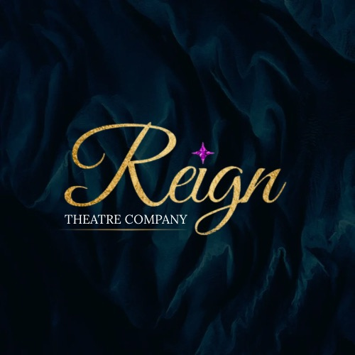

Complaints Procedure

Complaints Procedure Policy for Reign Theatre Company

Policy Statement:
At Reign Theatre Company, we are committed to providing a high standard of performing arts training/classes and service to all our students, parents, and staff. We value feedback and aim to resolve any concerns or complaints promptly, professionally, and fairly. This policy outlines the procedure for making and resolving complaints within the school.
Scope:
This procedure applies to all students, parents, guardians, staff, and visitors involved with Reign Theatre Company. It covers complaints relating to any aspect of the school's operations, including teaching, facilities, staff conduct, student welfare, and communication.
Objective:
To provide a clear, transparent, and effective process for addressing complaints, ensuring that they are dealt with in a timely and fair manner while maintaining confidentiality.

Stage 1: Informal Resolution
- Initial Discussion: If you have a concern or complaint, we encourage you to first discuss it informally with Principal Katie.
- Resolution: The aim is to resolve the issue quickly and informally. Staff are expected to listen, clarify the issue, and provide an appropriate response.
- Outcome: If the issue is resolved informally, no further action is required. However, if the matter cannot be resolved informally, the next step is to escalate the issue.
Stage 2: Formal Complaint
If the issue is not resolved through informal discussion, you may wish to make a formal complaint. This process ensures that complaints are properly investigated and addressed.
- Submission: Complaints should be made in writing (email or letter) to Principal Katie. Please provide as much detail as possible about the nature of the complaint, including dates, people involved, and any attempts made to resolve the issue informally.
  - Address complaints to: Katie Austwick, Principal of Reign Theatre Company
- Acknowledgment: The school will acknowledge receipt of your complaint within five working days. You will be informed of the process and the expected timeline for resolution.
- Investigation: The school will conduct a thorough investigation into the complaint. This may involve speaking with all parties involved and reviewing relevant documentation. The aim is to gather all facts before making a decision.
- Outcome: After the investigation, the school will provide a written response outlining the findings and any actions taken or planned. You will be notified of the outcome within 15 working days.
Stage 3: Appeal Process
If you are not satisfied with the outcome of the formal complaint procedure, you may appeal the decision.
- Appeal Submission: The appeal must be made in writing to the designated person, such as the school principal, within 7 working days of receiving the outcome.
- Appeal Review: A meeting may be held with the complainant, and further investigation may take place.
- Final Decision: You will be informed of the final decision, which may involve a further review of the complaint and any actions that may be taken. The final decision will be provided in writing.
Confidentiality:
The school takes complaints seriously and will treat all matters with confidentiality. Information will only be shared with individuals directly involved in resolving the complaint, unless required by law. All parties are expected to respect confidentiality during the process.
Safeguarding Complaints:
If the complaint concerns safeguarding or child protection, the school will follow its safeguarding policy and procedures. These issues will be treated as a priority and investigated in accordance with safeguarding protocols. Such complaints may need to be referred to external authorities such as social services or the police.
Unresolved Complaints:
If a complaint cannot be resolved internally, you may seek advice from external agencies such as the local education authority, Ofsted or other regulatory bodies depending on your location.
Timescales:
We aim to address complaints as quickly as possible. However, we recognize that more complex matters may require additional time for a thorough investigation. We will keep you informed of progress throughout the process.
Review and Monitoring:
The school will monitor and review complaints regularly to identify any patterns, improve services, and ensure the quality of our operations. This policy will be reviewed annually to ensure its effectiveness and relevance.

Signed: Principal Katie
Date: 02.02.2026

